 | Mathematics AC V9 — Year 5
Unit 1
Assessment task 1.2 — Exploring transformations and grid coordinates☼
The K–6 Curriculum Planning Model (K–6CPM) for Australian Curriculum V9 Mathematics supports systematic curriculum implementation in multilevel contexts across Kindergarten to Year 6. This flexible model streamlines content and assessments through aligned contexts.
The K–6CPM includes supplementary resources to support curriculum implementation in a range of schools including small schools and larger schools with complex and/or multilevel contexts.
This assessment task provides example questions and activities aligned to the aspects of the achievement standard being assessed. Individual school contexts will inform decisions about how the task is to be implemented and how students will engage with the task.
The assessment task gathers evidence of student learning for these aspects of the Year 5 Mathematics achievement standard:
- Use grid coordinates to locate and move positions.
- Perform and describe the results of transformations and identify any symmetries.*
*Denotes monitoring strategy within the task.
The following materials can be used when implementing Unit 1 in the K–6 Curriculum Planning Model Mathematics Year level plan example.
See the Mathematics Unit 1 Curriculum and assessment alignment planner (CAAP) to guide unit planning when developing a teaching and learning sequence and implementing the assessment in the unit.
Assessment conventions and resources
Purpose: To perform and describe transformation of shapes, identify symmetries and use grid coordinates.
Technique: Test
Conditions:
- This task is to be completed individually.
- Can be completed over multiple sessions.
- Adapt the mode and conditions to suit the diverse learning needs of your students and school context.
Other resources:
- Physical and virtual materials to perform transformations, for example: shapes, pattern blocks, interactive geometric software.
- Sheet — Australia map.

Mathematics teaching and learning resources
Visit the M in STEM website (https://det-school.eq.edu.au/m-in-stem) to access professional learning modules that support development of the mathematical proficiencies: Understanding, Fluency, Reasoning and Problem solving, including the mathematical processes: mathematical modelling, probability simulations and experiments, statistical investigations, and computational thinking.
Implementation advice
- Adapt this assessment task to suit the diverse needs of the students, school and local context.
- When adapting the assessment, maintain alignment to the targeted achievement standard aspects and aligned curriculum elements and consider ways to make the assessment meaningful and accessible for students.
- Answer spaces have not been included to provide flexibility in how and where students will respond.
- Each part of the summative assessment may be conducted as a series of smaller tasks to be used to gather evidence of student learning against the marking guide.
- A grid coordinate system uses numbered horizontal and vertical grid lines. Locations are defined using a set of numbered coordinates that indicate points where two grid lines meet. The coordinates are written in brackets with the horizontal coordinate first, followed by the vertical coordinate and separated by a comma.
- Prior to assessment, look at Sheet — Australia map and discuss the information with students.
For example:
- The states and territories are written with all capital letters, in grey font and marked by a dotted line.
- Capital cities are written with all capital letters, in black font and marked with a red dot.
- Towns are written with initial capital letters, in smaller black font and marked with a green dot.
☼ Source: Australian Curriculum www.australiancurriculum.edu.au, CC BY 4.0. © Australian Curriculum, Assessment and Reporting Authority (ACARA) 2010 to present, unless otherwise indicated. This material was downloaded from the Australian Curriculum website (www.australiancurriculum.edu.au) (Website) (accessed 15/10/24) and was modified. The material is licensed under CC BY 4.0 (https://creativecommons.org/licenses/by/4.0). Version updates are tracked in the ‘Curriculum version history’ section on the ‘About the Australian Curriculum’ page (http://australiancurriculum.edu.au/about-the-australian-curriculum/) of the Australian Curriculum website. ACARA does not endorse any product that uses the Australian Curriculum or make
any representations as to the quality of such products. Any product that uses material published on this website should not be taken to be affiliated with ACARA or have the sponsorship or approval of ACARA. It is up to each person to make their own assessment of the product, taking into account matters including, but not limited to, the version number and the degree to which the materials align with the content descriptions and achievement standards (where relevant). Where there is a claim of alignment, it is important to check that the materials align with the content descriptions and achievement standards (endorsed by all education Ministers), not the elaborations (examples provided by ACARA).

 | Mathematics AC V9 — Year 5
Unit 1
Assessment task 1.2 — Exploring transformations and grid coordinates

Name |  | Class
Teacher |  | Date
Part A: Perform and describe transformations and identify any symmetries
- Circle the shape that shows a reflection of the first shape.
- Circle the shape that shows a translation of the first shape.
- Circle the shape that shows a rotation a quarter turn clockwise of the first shape.

- Look at this shape.
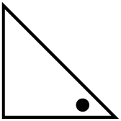
- Choose a way to transform this shape two times. Draw the shape after each transformation
(include the dot).
- Label each drawing to identify the movement and direction of the transformations.
- What is the symmetry in your drawings?
- Look at this shape.
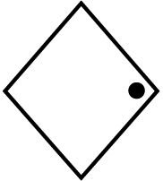
- Choose another way to transform this shape two times. Draw the shape after each transformation (include the dot).
- Label each drawing to identify the movement and direction of the transformations.
- What is the symmetry in your drawings?
- Look at this shape.
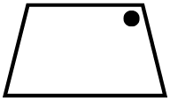
- Choose a third way to transform this shape two times. Draw the shape after each transformation (include the dot).
- Label each drawing to identify the movement and direction of the transformations.
- What is the symmetry in your drawings?
- Look at all of your transformations of shapes in questions 4–6.
- Describe what changes.
- Describe what stays the same.

- An arrow was transformed in four different ways from the start to the end. Look at the arrow’s position at the Start and at the End.
- Show a possible order of transformations to move the arrow.
Start |  |  |  | End
- Label your drawings to describe each transformation.
- Describe the symmetries shown after these transformations.
- Here is another arrow.
- Show another possible order of transformations to move the arrow.
Start |  |  |  | End
- Label your drawings to describe each transformation.
Part B: Use grid coordinates to locate and move positions
Use Sheet — Australia map to answer the following questions.
- Look at the map of Australia.
- What place is located at (16,1)?
- What are the grid coordinates for Adelaide?
- A plane departs from coordinates (19,6) and lands at (11,8).
- Mark the coordinates and draw the direct flight path on the map.
- What town did the plane depart?
- Where did the plane land?
- A pilot wants to travel from Katherine to Adelaide. They want to fly over Yulara to see Uluru and need to stop and refuel at Coober Pedy.
- Find and mark the locations on the map.
- Draw the direct flight path between each location.
- Create instructions for the pilot to use on their flight path from Katherine to Adelaide. Include grid coordinates, compass directions and distances.
- Look at the picture of the cat on grid paper.
- Label the coordinates on the horizontal and vertical axes on the grid.
- Label the grid coordinates of each point in the picture.
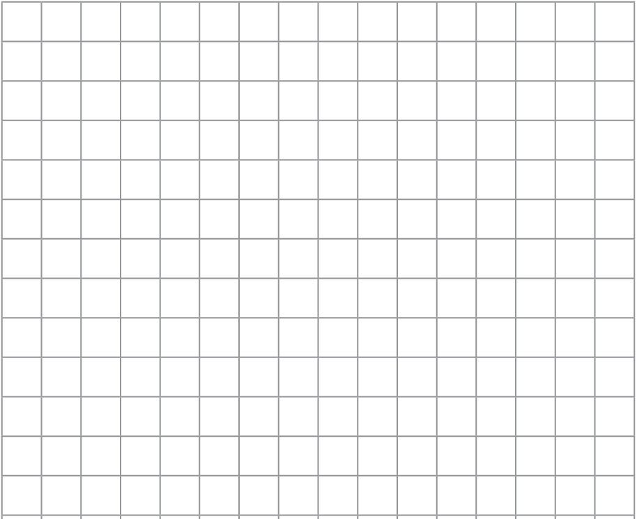
- Create instructions using the grid coordinates for another person to follow to recreate the picture.

 Marking guide — Year 5 Unit 1
AC V9 Mathematics | Name:
Assessment task 1.2 — Exploring transformations and grid coordinates☼
Purpose: To perform and describe transformation of shapes, identify symmetries and use grid coordinates.
 |  | Understanding and Fluency
Perform and describe the results of transformations and identify any symmetries.
Use grid coordinates to locate and move positions.
A | Performs and describes the results of combinations of transformations including describing how different combinations can produce the same resulting image, recognises what changes and what stays the same and describes symmetries.  Uses grid coordinates to locate and move positions, creates flight instructions using formal directional language and constructs own grid coordinate system and lists coordinates to recreate a picture.
B | Performs and describes the results of combinations of transformations, recognising what changes and what stays the same and describes symmetries.  Uses grid coordinates to locate and move positions and creates flight instructions using formal directional language.
C | Performs and describes the results of transformations and identifies any symmetries.  Uses grid coordinates to locate and move positions.
D | Performs and describes the result of a transformation and identifies one type of symmetry.  Uses grid coordinates to locate and describe positions.
E | Performs a transformation or identifies the result of a transformation.  Uses grid coordinates to locate a position.
Feedback:

Model response
The model response is a high-standard example. Different responses remain valid as long as students demonstrate the identified aspects of the achievement standard and standard descriptors of the marking guide.
Part A: Perform and describe transformations and identify any symmetries
- Circle the shape that shows a reflection of the first shape.
- Circle the shape that shows a translation of the first shape.
- Circle the shape that shows a rotation a quarter turn clockwise of the first shape.

- a–b. Look at this shape. Answers will vary, for example:
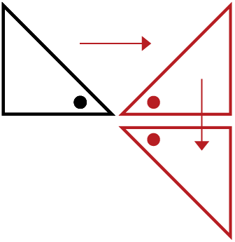 | Reflected horizontally to show a mirror image
 | Reflected vertically down
c. What is the symmetry in your drawings? Answers will vary, for example: Reflectional symmetry.
- a–b. Look at this shape.
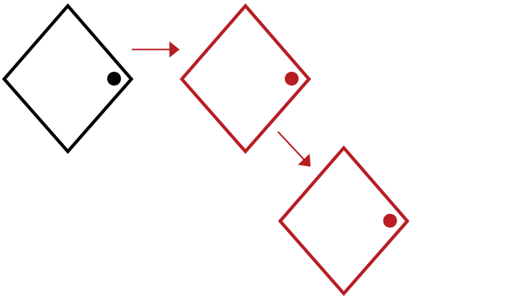  Slid diagonally down to the right  Moved to the right | This student has used arrows to show the sequence of transformations.
c. What is the symmetry in your drawings? Answers will vary, for example: Translational symmetry.
- a–b. Look at this shape.
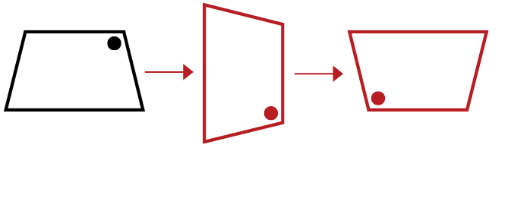
Rotated a quarter turn clockwise
Rotated another quarter turn clockwise
c. What is the symmetry in your drawings? Answers will vary, for example: Rotational symmetry.
- Look at all of your transformations of shapes in questions 4–6.
- Describe what changes.
The shapes have changed position and orientation during the transformations.
- Describe what stays the same.
The size and shape stayed the same.
- An arrow was transformed in four different ways from the start to the end. Look at the arrow’s position at the Start and at the End.
- Show a possible order of transformations to move the arrow. Answers will vary, for example:
Start |  |  |  | End
 | Reflect | Translate | Rotate a quarter turn clockwise | Rotate a quarter turn clockwise
- Label your drawings to describe each transformation.
- Describe the symmetries shown after these transformations.
Answers will vary, for example: I can see reflectional symmetry when the shape is reflected across a line of symmetry. I can see translational symmetry when the shape is moved to the right. I can see rotational symmetry when the shape is rotated a quarter turn clockwise and rotational symmetry again as the shape is rotated another quarter turn clockwise.
- Here is another arrow.
- Show another possible order of transformations to move the arrow. Answers will vary, for example:
Start |  |  |  | End
 | Rotate a quarter turn anticlockwise | Translate | Rotate a quarter turn anticlockwise | Reflect
- Label your drawings to describe each transformation.
Part B: Use grid coordinates to locate and move positions
Use Sheet — Australia map to answer the following questions.
- Look at the map of Australia.
This student has used grid coordinates to describe the position of Adelaide.
- What place is located at (16,1)? Hobart
- What are the grid coordinates for Adelaide? (13,5)
- A plane departs from coordinates (19,6) and lands at (11,8).
- Mark the coordinates and draw the direct flight path on the map. See map.
- What town did the plane depart? Port Macquarie.
- Where did the plane land? Coober Pedy.

- A pilot wants to travel from Katherine to Adelaide. They want to fly over Yulara to see Uluru and need to stop and refuel at Coober Pedy.
- Find and mark the locations on the map. See map.
- Draw the direct flight path between each location. See map.
- Create instructions for the pilot to use on their flight path from Katherine to Adelaide. Include grid coordinates, compass directions and distances.
Answers will vary, for example: Depart from Katherine at coordinates (10,15) and travel 1 250 kilometres south-west to coordinates (9,10). Then turn south-east and travel 500 kilometres to Coober Pedy at coordinates (11,8). On the way, you will fly over the town of Yulara and view Uluru from the air. After refuelling at Coober Pedy, travel 750 kilometres south-east and land in Adelaide at coordinates (13,5).
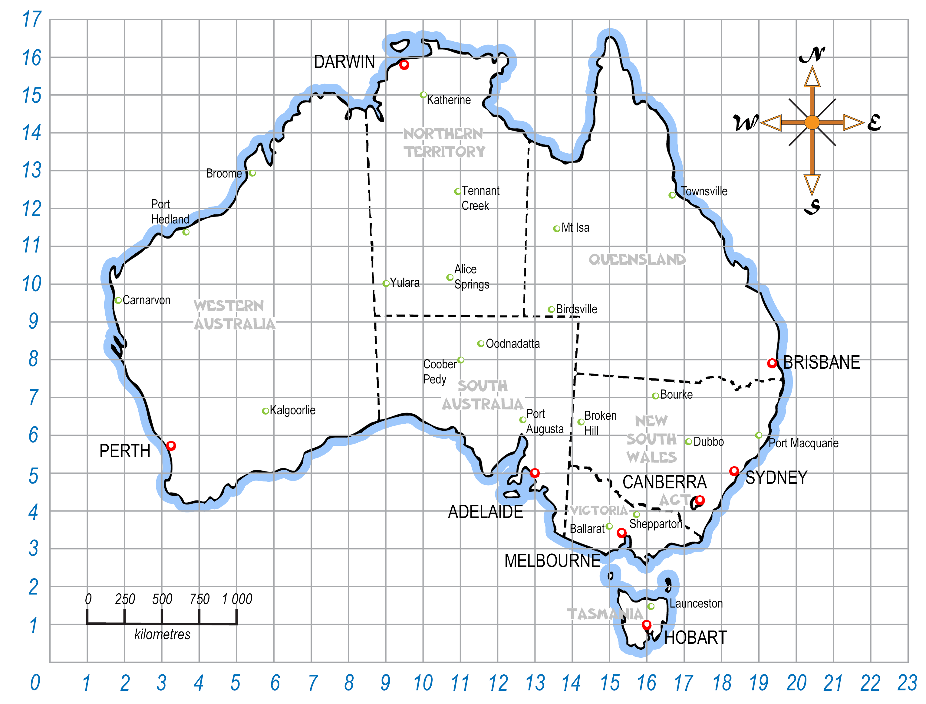
- Look at the picture of the cat on grid paper.
- Label the coordinates on the horizontal and vertical axes on the grid.
- Label the grid coordinates of each point in the picture.
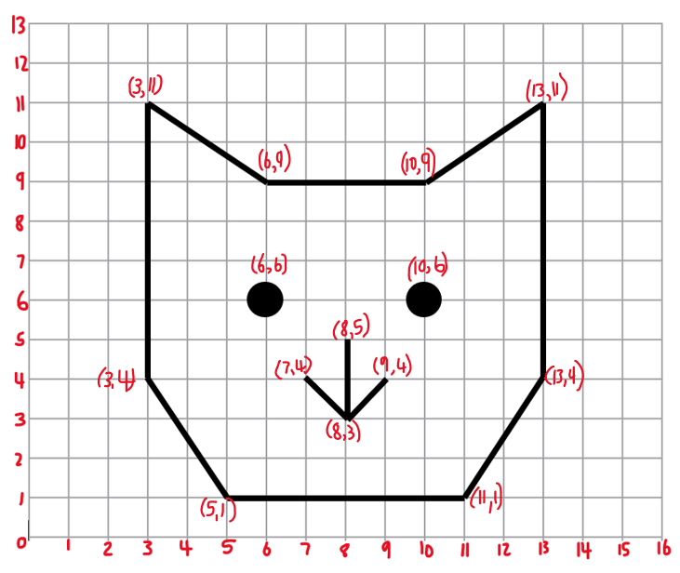
- Create instructions using the grid coordinates for another person to follow to recreate the picture.
Answers will vary, for example:
- For the face, start at (13,11) and draw a line down to (13,4).
- Draw a diagonal line to (11,1).
- Draw a line across to (5,1).
- Draw a diagonal line to (3,4).
- Draw a line up to (3,11).
- Draw a diagonal line down to (6,9) for the left cat ear.
- Draw a line across to (10,9).
- Draw a diagonal line up to (13,11) for the right cat ear.
- Draw a circle at (6,6) for the left eye.
- Draw a circle at (10,6) for the right eye.
- For the nose, start at (8,5) and draw a line down to (8,3).
- Draw a diagonal line from (7,4) to (8,3).
- Draw a diagonal line from (9,4) to (8,3).

 | Sheet
Australia map


